OUT OF THE BOX - Cardboard Art Project
Cardboard is a mundane material, so often cast off and thrown away or recycled – but some artists have transformed it into objects that are anything but disposable. From expressive little faces made of toilet paper tubes to an entire cardboard city, these works of art range from temporary installations to durable sculptures that are imaginative and eco-friendly.
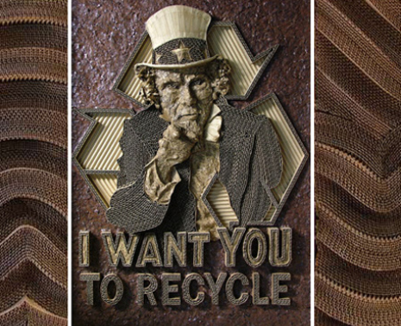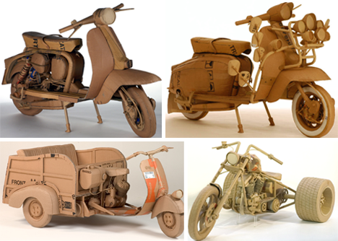
Read the following articles:
http://weburbanist.com/2009/10/19/12-cardboard-artists-who-think-outside-the-box/
http://weburbanist.com/2008/11/28/cardboard-art-and-sculptures/
http://weburbanist.com/2009/12/26/tiny-magical-worlds-inside-toilet-paper-rolls/
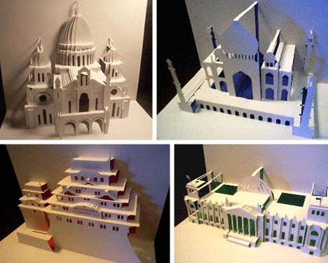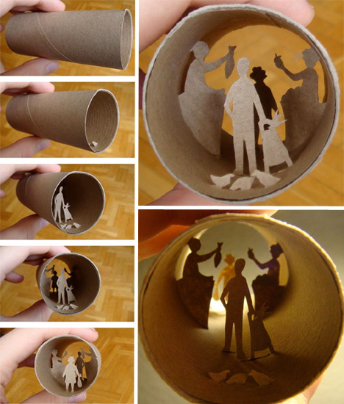
STEP ONE - READ articles and Rubric, select one sculpture that “speaks to you” and fill out Research Sheet and all of the answer questions!! (complete sentences)
STEP TWO: BRAINSTORM possible subject matter for your Sculpture – Please note that is you decide on toilet paper tube vignettes that you must do at least 3
STEP THREE: DRAW at least 3 different conceptual designs of possible subject matter. Consider how you will break down your chosen subject matter using different shapes and forms using expressive line three dimensionally. FRONT VIEW, SIDE VIEW AND BACK VIEWS
STEP FOUR: GET APPROVAL from the teacher on one of your conceptual sketches to be developed further as a three-dimensional sculpture.
STEP FIVE: SCULPT your cardboard.
STEP SIX: COMPLETE all QUESTIONS related to your process and work.
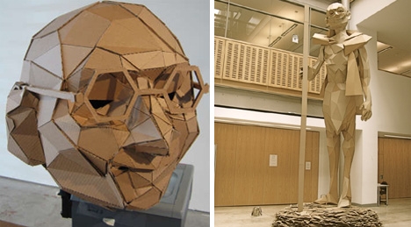

Cardboard Art Research Sheet
Name ____________
Select one cardboard sculpture from the sites provided and identify the formal, expressive and technical qualities of the work.
Artist’s Name __________________ Title of Artwork ______________

Thumbnail sketch Thumbnail sketch

Formal Qualities: (How are the elements and principles used: (Line, Shape, Form, Texture, Balance, Rhythm, Pattern, Contrast, Emphasis, Value, Space, Movement, Colour, Variety, Proportion, Unity)

Expressive Qualities: (mood/feeling):

Technical Qualities: (how was it created):

Your Cardboard Sculpture Title _____________________
Formal Qualities: (How are the elements and principles used: (Line, Shape, Form, Texture, Balance, Rhythm, Pattern, Contrast, Emphasis, Value, Space, Movement, Colour, Variety, Proportion, Unity)

Expressive Qualities: (mood/feeling):

Technical Qualities: (how was it created):

Connections to the work you studied:

Describe the stages of the design process (research, conceptual sketches, experimentation, revision(s)) followed in the creation of your sculpture.

REFLECT by answering the following questions:
1. What do you think was the most successful part of your sculpture and why?
2. What do you think was the least successful part of your sculpture and why?
3. If you had to do this project again, what changes would you make to your sculpture and why?
Another artist to look at –
Ian Trask is a scientist-turned-artist. His sculptures transform materials of waste and commercial by-products into refined aesthetic objects.
http://www.iantrask.com/cardboard-installations/y6pc0fyhybj2af9xh1gh9pxhdhv5gj
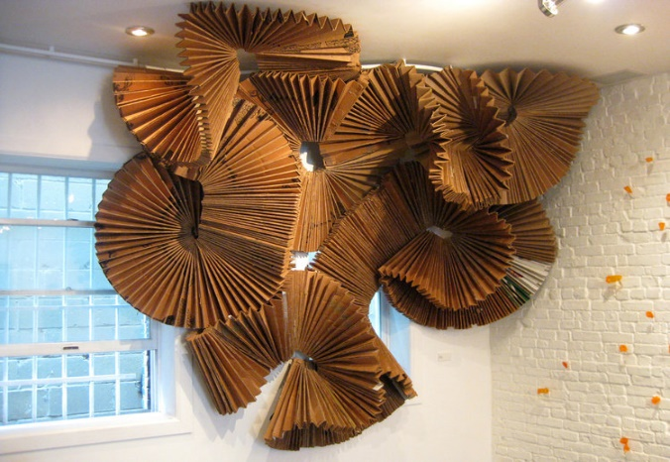
Variable

