Complex Origami
What did Leonardo daVinci, Lewis Carroll and Fredrich Froebel (the guy who created “kindergarten”) all have in common? Origami! From its ancient origins in Japan to its practice by the Moors of Northern Africa during the middle ages and its recent surge in popularity, origami has delighted artists, mathematicians, architects, and educators worldwide.
Learn the folds, explore the mystery, geometry and joy of origami through artistic experimentation in this project.
Complex Origami
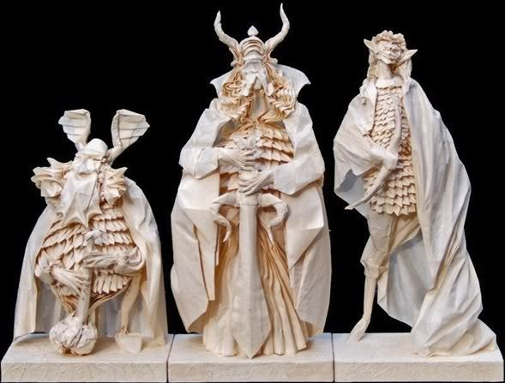
“If one isn’t an origami folder, it’s difficult to explain the process of conception through to the finished model. The creation process is similar to a scientific method. When designing a person, one begins with the assumption that the four corners of the paper will represent each hand and foot. From that general assumption, a “crease pattern” is developed that blueprints all the folds required for the model. These crease patterns may be modified while the model takes shape…”
Can you believe it? One paper…! Extract from Eric Joisel November 7, 2007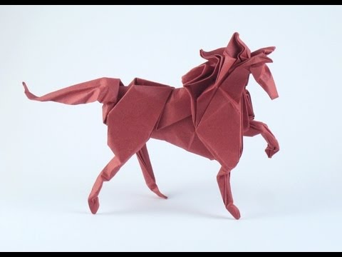
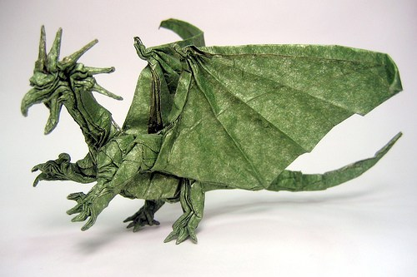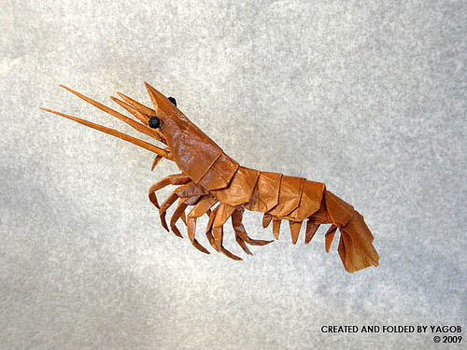
STEP 1: RESEARCH online to plan and find videos with demonstrations to help you in learning folds and process. RECORD the sites you use. See below –
EXAMPLE:
Sites I used for my experimentation and exploration:
- https://www.grupoetor.org/lovely-complex-origami-instructions/folding-instructions-origamiyoda-complex-origami-instructions-advanced-origami-instructions/
STEP 2: CREATE a plan for a complex set of origami creatures or creations – sketch.
STEP 3: EXPERIMENT with folding processes and learn the basics needed to complete your creation.
STEP 4: CREATE your PAPER SCULPTURE
