Sketchbook Criteria and Ideas
Drawing is the basis for all artwork whether it is done mentally or physically. It is the basis for painting, printmaking, sculpture, design, ceramics and weaving. Since drawing is such an important step in the process of making art it is a huge part of your curriculum in high school art. The more it is done the better your observational skill develops, as well as your eye-to-hand coordination. Try to draw at least 15 minutes per day to progress and improve.
This course requires you to submit a sketchbook at the end of the semester of at least 20 to 30 individual pieces.
Ideas for drawing in your sketchbook – see Mrs. Lamb for handouts on more detailed instruction.
1. Look at things around your home – dishes, boots, pile of books, vases, quilt thrown over a chair, sofa…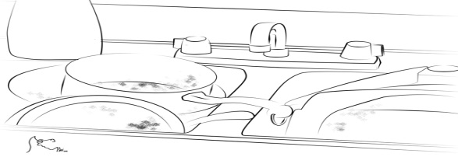
2. Nature – pine cone, seed pod, houseplant, vegetable or fruit cut in half …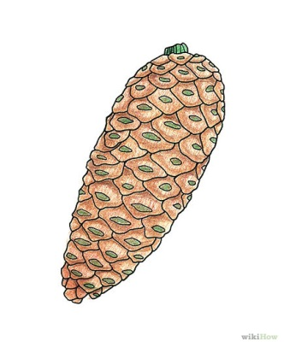
3. People – in a mall, sporting event, café, … or portraiture – see below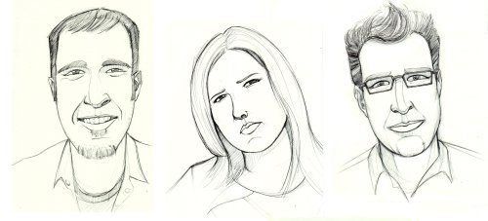
4. Animals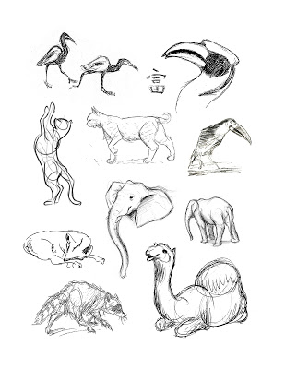
ETC.
For example;
Landscape doesn't just mean hills and trees. Landscape can include any outdoor scene from wilderness and farmland through to suburban views and urban cityscapes. It can encompass a broad vista and distant mountaintops or just the details of a tree. Here are some landscape drawing ideas to get you started.
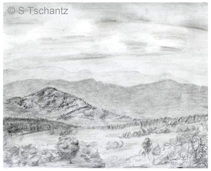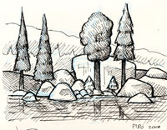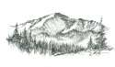
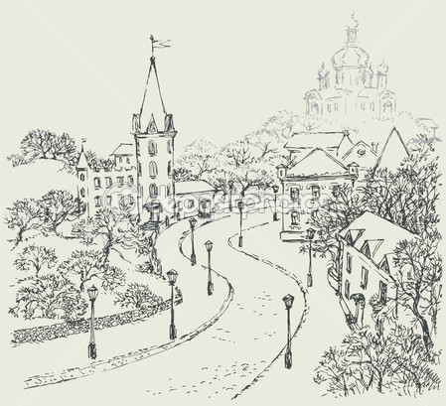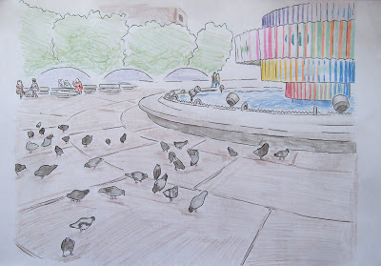

A Classic Landscape
'Typical' depends on where you live - here in Alberta mountains are not usually hard to find so you can use the basic elements of a country landscape, with foreground, middle ground and background easily. We look for distant hills or horizon, and an interesting shape created by groups of trees or hills, and some foreground detail to add contrast. This is the foundation of the classic landscape.

