Space and Nature Monoprints

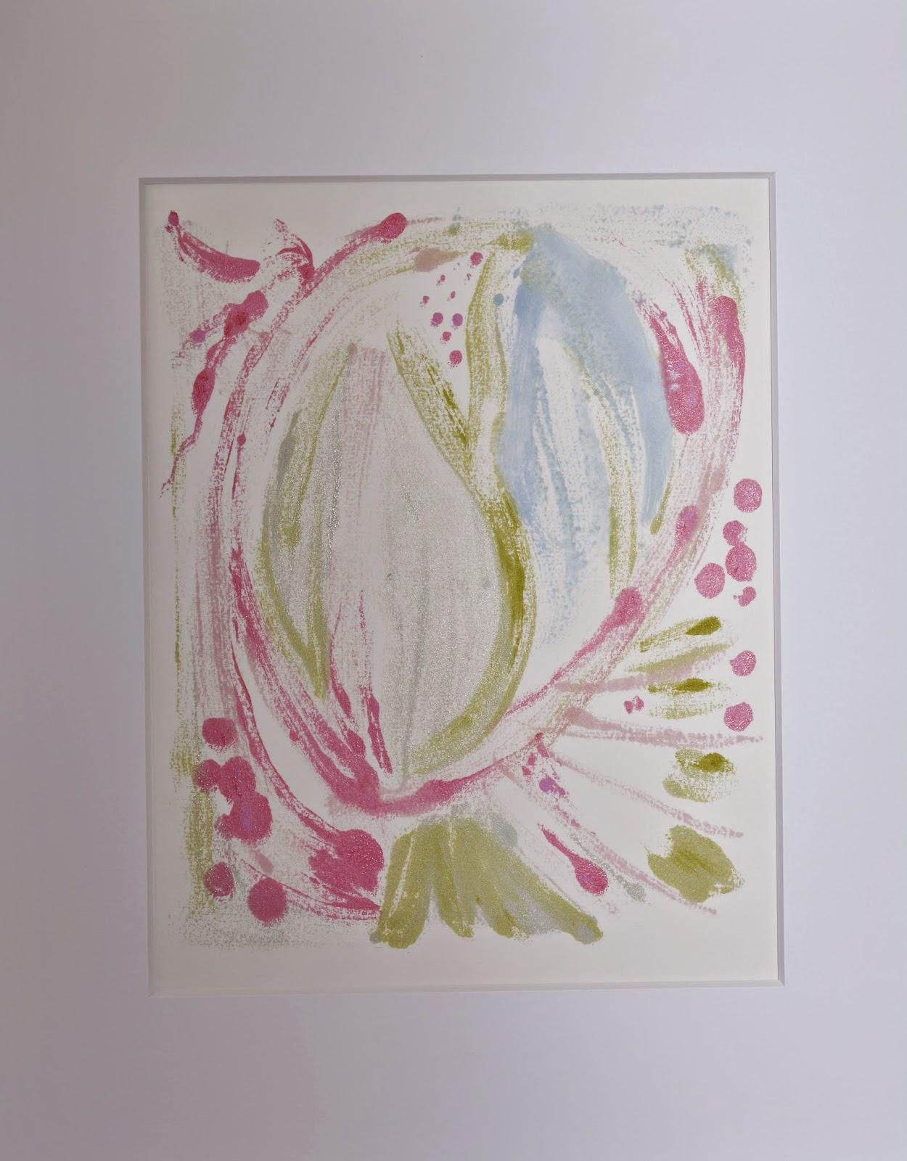 Nettle
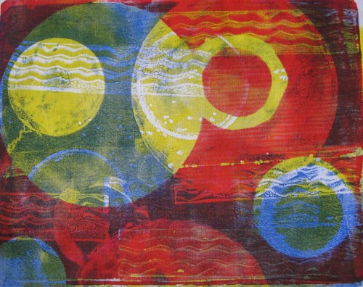 Solar Space by Heather Holland
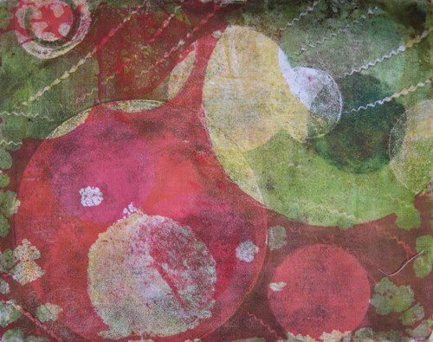 Comets
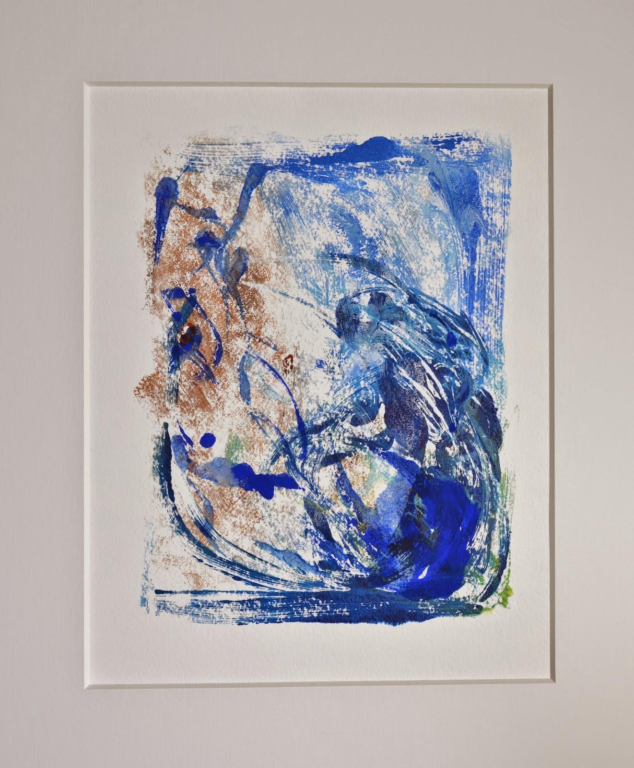 Prairie Grass
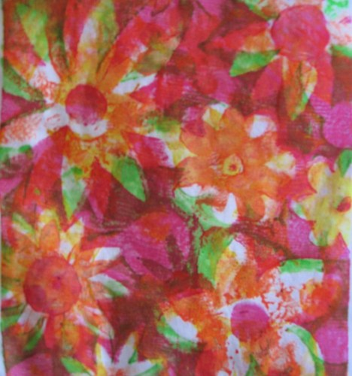Fluoro Floriade

Chickadee and Salamander https://biocreativity.wordpress.com/2011/12/
Space http://portfolios.risd.edu/gallery/3850487/Monotypes-of-space

