“T.S. Eliot wrote, “Genuine poetry can communicate before it is understood,” and for me, the poem that has always communicated with me is Ulysses, by Alfred Lord Tennyson.
I first read it in my late teens and then read it again in my 20s. It was a formative time as I was trying to determine who I was, what I stood for, and what type of life I wanted to lead. Tennyson’s words filled me with a fire to lead a life of purpose. It has taught me to be a thinker and “follow knowledge like a sinking star beyond the utmost bounds of human thought.” It has warned me of the dangers of being passive, “how dull it is to pause, to make an end, to rust unburnish’d, not to shine in use!” It has also encouraged me to never let a weakness cripple my will to achieve, “that which we are, we are;/ One equal temper of heroic hearts,/ Made weak by time and fate, but strong in will.”
Time and time again I have returned to it, and its inspiration has never disappointed. I hoped, in turn, to use it to inspire you.”

It Came from Greek Mythology

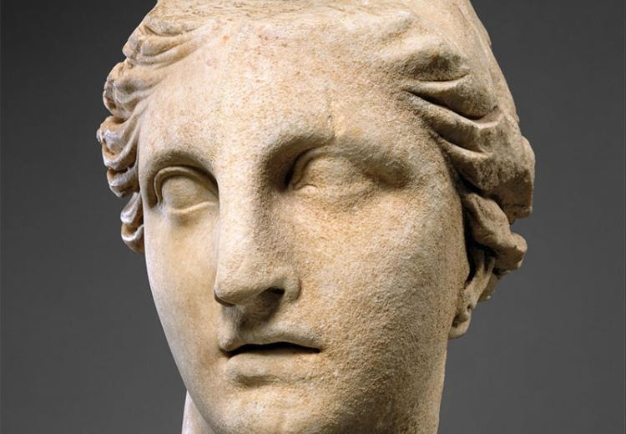

"And when I was a schoolchild, I loved those old stories ... They have mystery, treachery, murder, loyalty, romance, magic, monsters—everything is in there. So I can’t remember a time when I wasn’t interested in mythology and that just continued when I was a teacher." — Rick Riordan, Episode for Families: Percy Jackson & the Olympians: The Lightning Thief at the Met
https://www.metmuseum.org/metmedia/video/collections/gr/percy-jackson Great to watch, especially if you want to write - start at 3:05
Monsters, gods, and heroes ... all sure-fire favorites in the classroom and the stuff of Greek mythology. But Greek mythology offers so much more: inspiration for many works of art (both written and visual), insight into the human condition, a glimpse at an ancient people trying to make sense of phenomena they could not explain, and the source for many names and terms we use today. You might be surprised to find you're wearing shoes with the name of a Greek goddess (Nike), rooting for (or against) a team named after Greek gods (Tennessee Titans), and even listening to rock groups with mythological names (Styx).
Guiding Question - What meanings do the Greek myths have for us today?
Learning Objective -Analyze a literary work based on or inspired by Greek myths.

Background
Heroes were an important part of Greek mythology, but the characteristics Greeks admired in a hero are not necessarily identical to those we admire today. Greek heroes are not always what modern readers might think of as "good role models." Their actions may strike us as morally dubious. For example, in his encounter with the Cyclops, Odysseus helps himself to the giant's food without permission, attacks while the Cyclops is in a wine-induced stupor, and brags about blinding the one-eyed creature. This does not mean the Greeks admired thievery and bragging, however. What they admired about Odysseus, in this instance, was his capacity for quick thinking. Odysseus defied that which others would not (as is also shown by his desire to hear the Sirens' song) and pulled off great feats with panache and self-confidence.
Although myths convey exciting stories about gods and heroes, they are not equivalent to "stories" either in the modern sense of a deliberate fiction or the traditional sense of a folk tale or tall story. Rather, myths are traditional narratives often of gods, goddess, and heroes, great deeds and supernatural powers, that are passed down through various textual and visual sources and convey commonly held beliefs in a particular society about natural phenomena, historical events, and proper behavior.
The Greek myths were not composed as stories for children. Not all Greek heroes were admired for the same reasons. Some, such as Odysseus, were admired for their resourcefulness and intelligence, whereas others, such as Herakles, were known for their strength and courage. Some were not particularly resourceful, but depended on help to accomplish their tasks.
Whether or not a given action or quality was admired depended upon its ultimate results. Being headstrong might succeed in one instance, but lead to failure in another. The Greeks held their characters accountable for their actions, and a hero might be punished as well as rewarded.

Literary Works Related to Odysseus Texts

https://www.sacred-texts.com/cla/bulf/bulf28.htm

Definition of Dramatic Monologue https://www.sacred-texts.com/cla/bulf/bulf28.htm

Ulysses

Tennyson, Alfred Lord (1809 - 1892)
Original Text:
Alfred lord Tennyson, Poems, 2 vols. (Boston: W. D> Ticknor, 1842). PR 5550 E42a Victoria College Library (Toronto). Alfred lord Tennyson, Works (London: Macmillan, 1891). tenn T366 A1 1891a Fisher Rare Book Library (Toronto).
1It little profits that an idle king,
2By this still hearth, among these barren crags,
3Match'd with an aged wife, I mete and dole
4Unequal laws unto a savage race,
5That hoard, and sleep, and feed, and know not me.
6I cannot rest from travel: I will drink
7Life to the lees: All times I have enjoy'd
8Greatly, have suffer'd greatly, both with those
9That loved me, and alone, on shore, and when
10Thro' scudding drifts the rainy Hyades
11Vext the dim sea: I am become a name;
12For always roaming with a hungry heart
13Much have I seen and known; cities of men
14And manners, climates, councils, governments,
15Myself not least, but honour'd of them all;
16And drunk delight of battle with my peers,
17Far on the ringing plains of windy Troy.
18I am a part of all that I have met;
19Yet all experience is an arch wherethro'
20Gleams that untravell'd world whose margin fades
21For ever and forever when I move.
22How dull it is to pause, to make an end,
23To rust unburnish'd, not to shine in use!
24As tho' to breathe were life! Life piled on life
25Were all too little, and of one to me
26Little remains: but every hour is saved
27From that eternal silence, something more,
28A bringer of new things; and vile it were
29For some three suns to store and hoard myself,
30And this gray spirit yearning in desire
31To follow knowledge like a sinking star,
32Beyond the utmost bound of human thought.
33 This is my son, mine own Telemachus,
34To whom I leave the sceptre and the isle,--
35Well-loved of me, discerning to fulfil
36This labour, by slow prudence to make mild
37A rugged people, and thro' soft degrees
38Subdue them to the useful and the good.
39Most blameless is he, centred in the sphere
40Of common duties, decent not to fail
41In offices of tenderness, and pay
42Meet adoration to my household gods,
43When I am gone. He works his work, I mine.
44 There lies the port; the vessel puffs her sail:
45There gloom the dark, broad seas. My mariners,
46Souls that have toil'd, and wrought, and thought with me--
47That ever with a frolic welcome took
48The thunder and the sunshine, and opposed
49Free hearts, free foreheads--you and I are old;
50Old age hath yet his honour and his toil;
51Death closes all: but something ere the end,
52Some work of noble note, may yet be done,
53Not unbecoming men that strove with Gods.
54The lights begin to twinkle from the rocks:
55The long day wanes: the slow moon climbs: the deep
56Moans round with many voices. Come, my friends,
57'T is not too late to seek a newer world.
58Push off, and sitting well in order smite
59The sounding furrows; for my purpose holds
60To sail beyond the sunset, and the baths
61Of all the western stars, until I die.
62It may be that the gulfs will wash us down:
63It may be we shall touch the Happy Isles,
64And see the great Achilles, whom we knew.
65Tho' much is taken, much abides; and tho'
66We are not now that strength which in old days
67Moved earth and heaven, that which we are, we are;
68One equal temper of heroic hearts,
69Made weak by time and fate, but strong in will
70To strive, to seek, to find, and not to yield.

Notes
1]
"Ulysses was written soon after Arthur Hallam's death, and gave my feeling about the need of going forward, and braving the struggle of life perhaps more simply than anything in In Memoriam" (Tennyson). Based on a passage in Dante's Inferno, canto XXVI. Hallam had drawn Tennyson to a study of Dante. Tennyson exalts his hero's eternally restless aspiration, whereas Dante condemned his curiosity and presumption. Both poets recalled Odyssey, XI, 100-37, where the ghost foretold Ulysses' fortune.
10]
Rainy Hyades: a group of stars which rise with the sun in spring at the rainy season.
34]
the isle: Ithaca, of which Ulysses was king.
60]
the baths: the place where the stars seem to plunge into the ocean.
62]
wash us down: The ocean was imagined by Homer as a river encompassing the earth, and on the west plunging down a vast chasm where was the entrance of Hades.
63]
the Happy Isles: the islands of the blessed, supposed to lie to the west of the Pillars of Hercules, i.e., in the Atlantic.
Publication Start Year:
1842
RPO poem Editors:
H. M. McLuhan
RPO Edition:
3RP 3.45.
Rhyme:
Unrhyming

Questions
- How does Ulysses spend his time at home?
- What does Ulysses miss about his past?
- What plans does Ulysses have for his son Telemachus?
- To whom is Ulysses speaking in the poem?
- What does Ulysses want his listeners to do with him?
- How does Ulysses feel about his life at home? Use evidence from the poem to support your answer.
- Explain what the following lines mean:
18 I am a part of all that I have met;
19 Yet all experience is an arch wherethro'
20 Gleams that untravell'd world whose margin fades
21 For ever and forever when I move.

- Does Ulysses approve of his son’s approach to life? How can you tell?
- Sum up Ulysses’ thoughts and feelings about aging. Support your answer with evidence from the poem.
- What arguments does Ulysses present to persuade his listeners to join him? Did you find his arguments persuasive? Explain why or why not?
- What character would you rather have as a ruler, Ulysses or Telemachus? Why?

Video - only goes so far, but is okay - some controversy discussed
https://study.com/academy/lesson/tennysons-ulysses-a-victorian-take-on-greece.html

