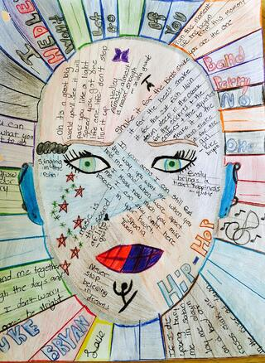

STEP 1: Establishing Personal Identity and Values Through Self-Portrait

You will begin the project by creating a self-portrait that is both a visual and literary expression of self. In the portrait, you need to identify 1. what you value, 2. who you value, and 3. how you believe others see you. From the self-portraits, I want to be able to identify you, without searching for your name.
This is probably the most important step in the project. It will communicate your values, beliefs, ethnic or community origins, and passions. This will prove to be the most valuable self-reflection you do in this grade level.

