STEP 2: 10 Defining Moments
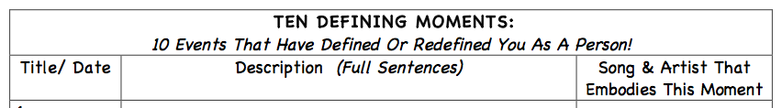

Through the next portion of the project, you need to explore defining moments, critical choices, pivotal people, and memorable places that have helped to shape your personal identities. Link that to a song or artist that embodies that moment for you. We are often linked to music or art in our lives which occurs at those moments.

Defining Moments
https://www.scc-csc.ca/judges-juges/spe-dis/bm-2013-02-05-eng.aspx
https://www.canadianliving.com/life-and-relationships/community-and-current-events/article/canadian-celebrities-favourite-moments-from-2011

Think about your own defining moments, and how sometimes they are the most difficult ones that we go through.

Brainstorm some of these moments yourselves. Others usually start with birth, but often explore successes, failures, arguments, injuries, holidays, events, wishes which came true, etc.
Pick the TOP 10 you totally know defined you and record them clearly – you might need a few lines. Organize in a Google Doc as outlined in the chart above. Tag a song or artist or artwork or movie… that relates to that for you.

