Social Justice or Social Consciousness Painting
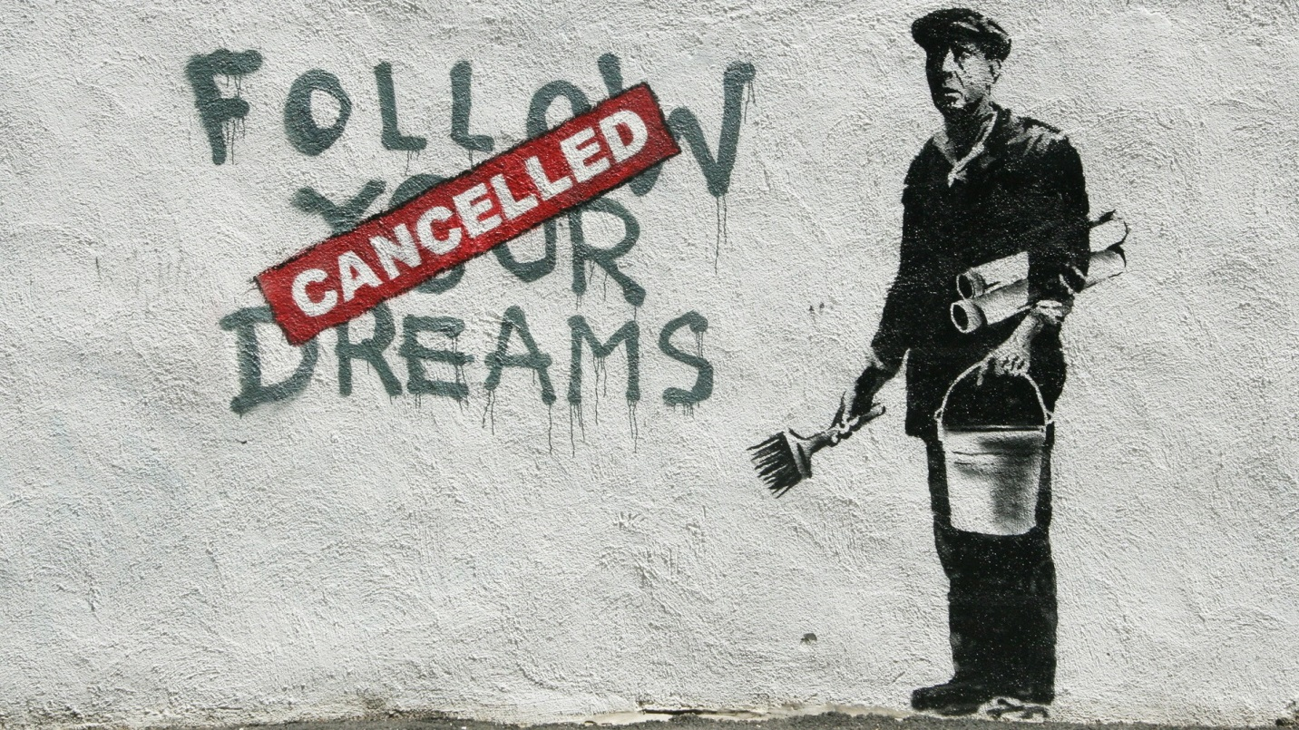
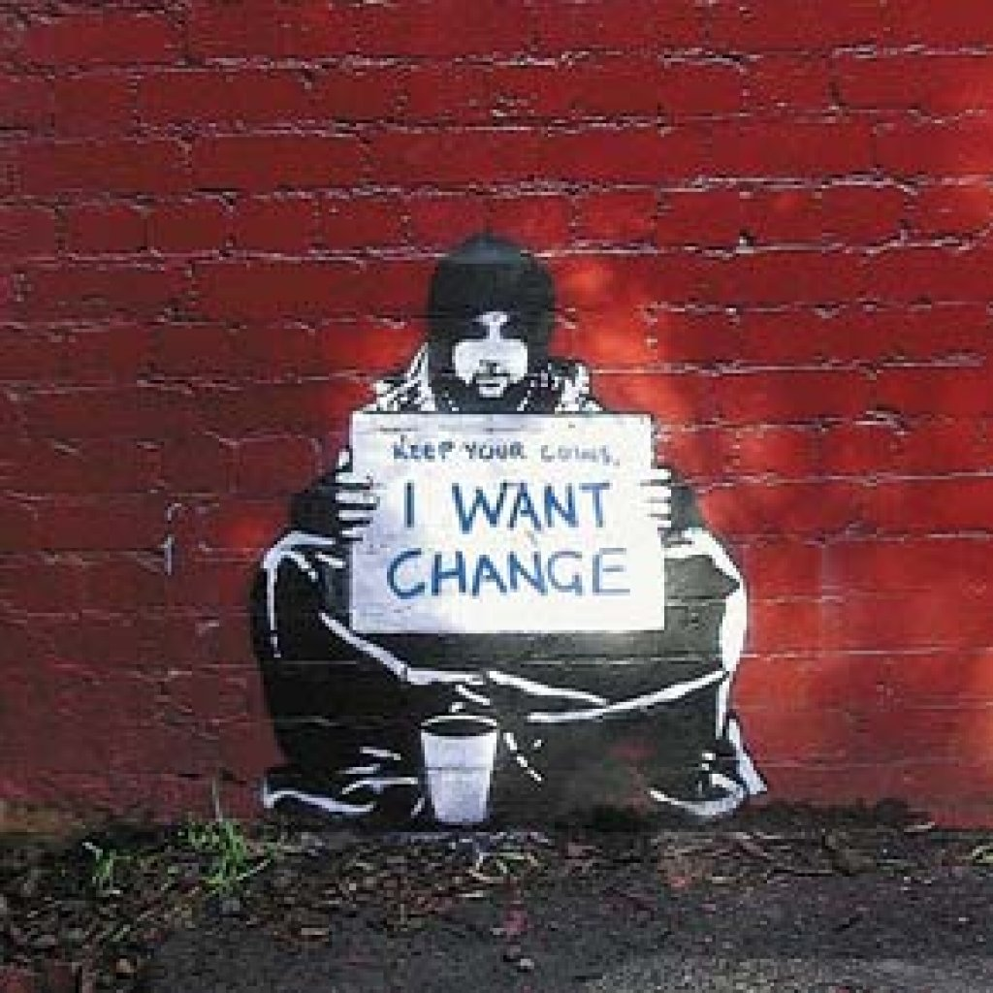
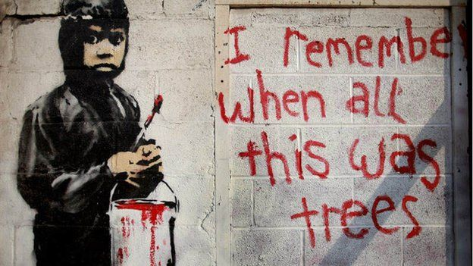
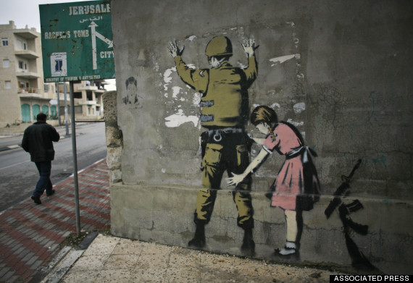
Bansky art
Brazilian Street Art
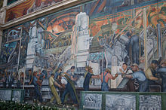
Diego Rivera - Detroit Industry Murals

Art City Asks: Nicolas Lampert
By Nathaniel Stern, Art City contributor
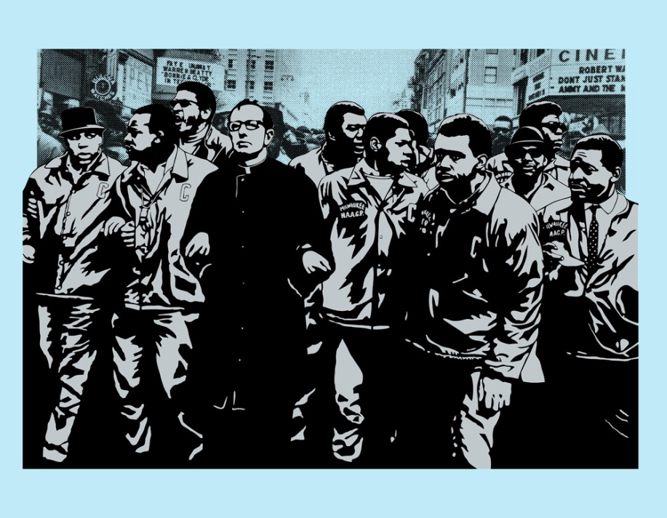
Nicolas Lampert is an artist who in many ways is an old fashioned radical. He addresses issues related to urban ecology and social justice, among other things, and tends to believe radical culture should challenge mainstream culture. His activism and his art are intertwined.
He works with art collectives and social justice movements, such as the Justseeds Artist Cooperative, a group of 25 political printmakers across North America, the Rain Forest Action Network and Iraq Veterans Against the War, among others.
He was commissioned to do a public art project at the Villard Avenue Public Library with Paul Kjelland. The opening celebration, Lampert said, was more satisfying to him than having a show at MoMA might be.
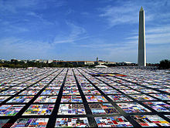
The Aids Quilt Project

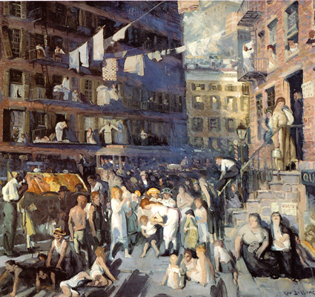
Cliff Dwellers by Georges Bellows
Other examples can be found on; http://culturalpolitics.net/environmental_justice/art

