Altered Book Sculpture NAME: ______________
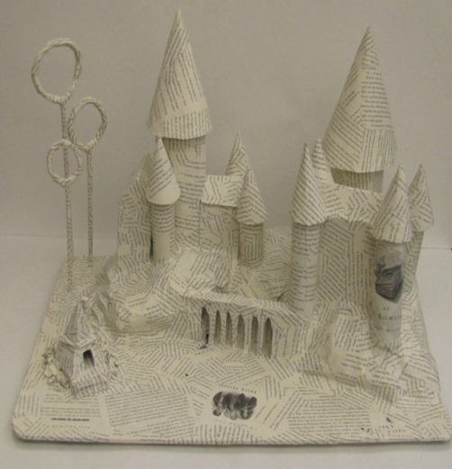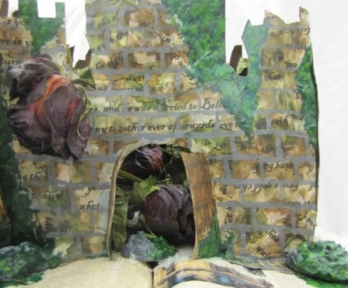  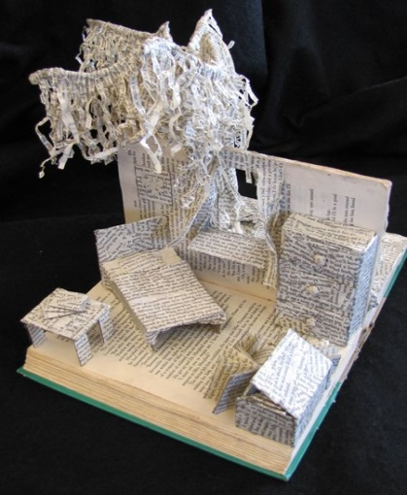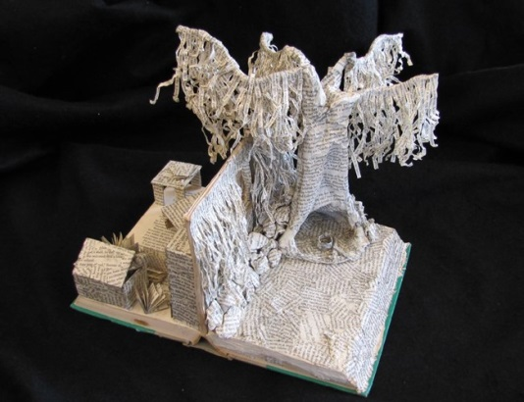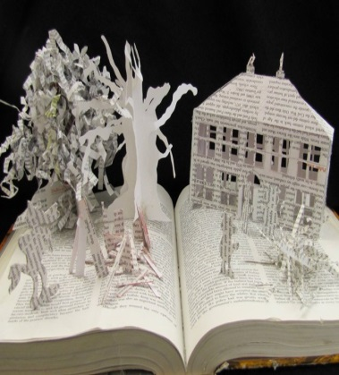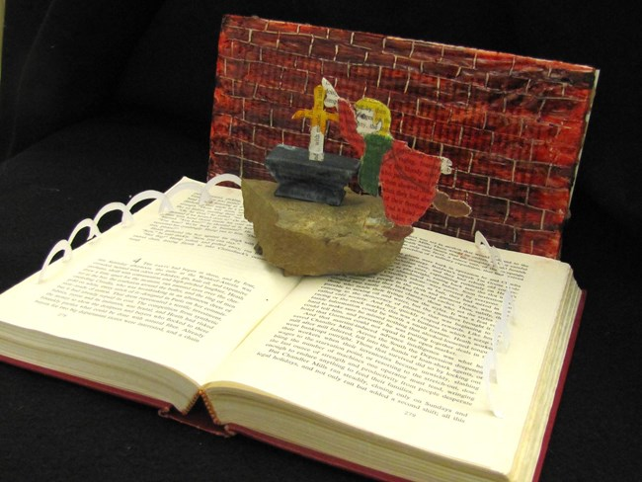 | Paper Mache: is a French term that means "chewed paper". It is a substance made of pulped paper or paper pulp mixed with glue and other materials or of layers of paper glued and pressed together, molded when moist to form various articles, and becoming hard and strong when dry.  STEP ONE: Think about a story or book you really enjoyed. What was the scene in your mind you remember the most? What were the elements or structures in the scene? How would you create the objects?  STEP TWO: Create 3 sketches of the scene. Think about how you will use the base book to create the scene? Think about the base book in the round....How would you manipulate the pages, binding, and or add materials to expand the book?  STEP THREE: Use various objects, including pages from some of the books or magazines, and watered down white glue to create the “setting”.  Create armatures (support backings) if necessary to support the structures for the scene.  Do you need color? Use acrylic paint once the glue is dry.  STEP FOUR: REFLECT on your finished work by answering the following questions:  - What part of your finished project did you find most successful and why?  - What part of your finished project did you find least successful and why?  - If you had to do this project again what part would you change or improve upon and why?  CONSIDER: Detail in shape and form. 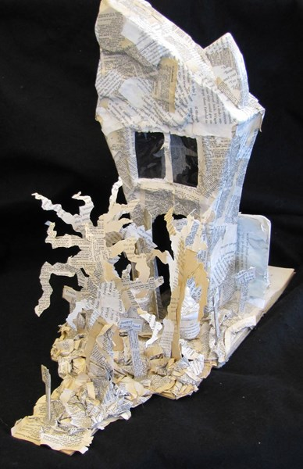  Name ____________  Achievement Criteria Level 0 Level 1 Level 2 Level 3 Level 4  Thinking/Inquiry Concept & Meaning: Work does not meet assignment expectations for this category. Incomplete. Student depicts scene from a book with limited effectiveness. Student depicts scene from a book with some effectiveness. Student depicts scene from a book with considerable effectiveness. Student depicts scene from a book with a high degree of effectiveness /1  Knowledge/ Understanding Work does not meet assignment expectations for this category. Incomplete. Student demonstrates limited understanding of the elements & principles of design in sculpture. Student demonstrates some understanding of the elements & principles of design in sculpture. Student demonstrates considerable understanding of the elements & principles of design in sculpture. Student demonstrates a high degree of understanding of the elements & principles of design in sculpture. /1  Application/ Creation Process: Demonstration of skill development and following Procedures including clean up Completion/ Neatness Detail – uses elements and principles of design and sculpture techniques to produce an effective artwork – shape and form Work does not meet assignment expectations for this category. Incomplete. 0 Incomplete 0 Incomplete 0 Preliminary sketches are poor/incomplete. Planning is tentative or non-existent. 0.5 Student demonstrates limited effectiveness in demonstrating the creative process and following procedures 4 Limited details /1 Preliminary sketches are Somewhat clear and complete. Planning is somewhat substantial & shows some alternative ideas. 1 Student demonstrates some effectiveness in demonstrating the creative process and following procedures 5-6 Some demonstrating of details present 2-3 Preliminary sketches are mostly complete. Concepts are complete. Planning is evident & shows some divergent thinking. 1.25-1.75 Student demonstrates considerable effectiveness in demonstrating the creative process and following procedures 7-8 Demonstrates considerable and effective details /4 Preliminary sketches are thorough & complete. Concepts are fully developed. Planning is exceptional & shows considerable flexibility in thinking 2 Student demonstrates superior effectiveness in demonstrating the creative process and following procedures 9-10 High degree of details present and art work is highly effective /5 /2 /10 /5  Reflection Questions Incomplete 0 Poor, Yes/No answers/ limited/ incomplete 0.25 Somewhat coherent and somewhat complete 0.50 Clear and substantial answers 0.75 Superior and insightful answers 1 /1  /20

