Group of Seven Painting Study NAME:__________________
This project involves you examining the art of Canada’s Group of Seven and then recreating a copy of one artist’s work.
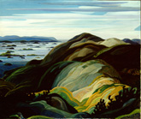

- The Group of Seven
  - Tom Thomson
  - Lawren Harris
  - J.E.H. MacDonald
  - Arthur Lismer
  - Frederick Varley
  - Frank Johnston
  - Franklin Carmichael
  - A.Y. Jackson
  - A.J. Casson
  - Edwin Holgate
  - L.L. Fitzgerald

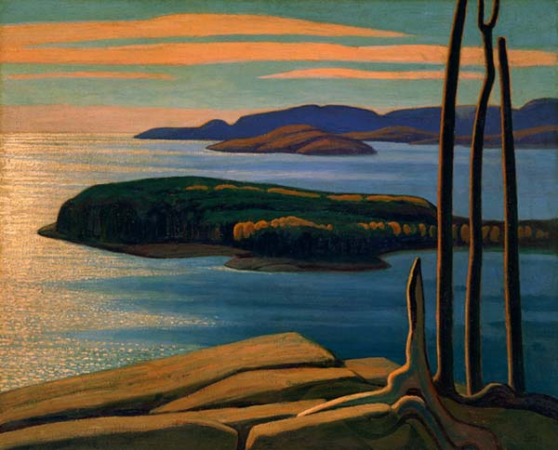
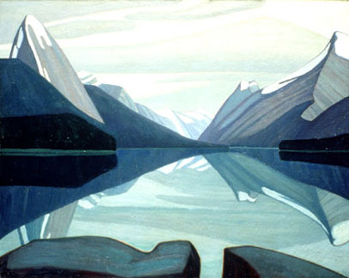
In the early decades of the twentieth century, circumstances brought together several artists who were committed to exploring, through art, the unique character of the Canadian landscape. Collectively they agreed: Canada’s rugged wilderness regions needed to be recorded in a distinctive painting style. This style would break from European tradition and reflect an increasingly nationalistic sentiment (ie; “WE ARE CANADIAN”). Originally there were seven, but more joined the group as years passed.
Today, these men are among Canada’s most famous artists. For many, their works have come to symbolize what is the distinctly Canadian identity.
STEP ONE: Begin researching Group of Seven artists and art. Think about which artist’s work you work like to replicate. Complete the Artistic Statement Template.
STEP TWO: Print off a copy of your selection. Grid the printed selection. Grid the canvas quality paper lightly. Copy your selection onto the canvas quality page – 30 cm by 24 cm.
STEP THREE: Using acrylic paints, use various painting techniques to complete a “copy”.
STEP FOUR: REFLECT: Answer the following questions using the elements and principles of design.
- What part of your finished project did you find most successful and why?
- What part of your finished project did you find least successful and why?
- If you had to redo this project, what part would you change or improve on and why?
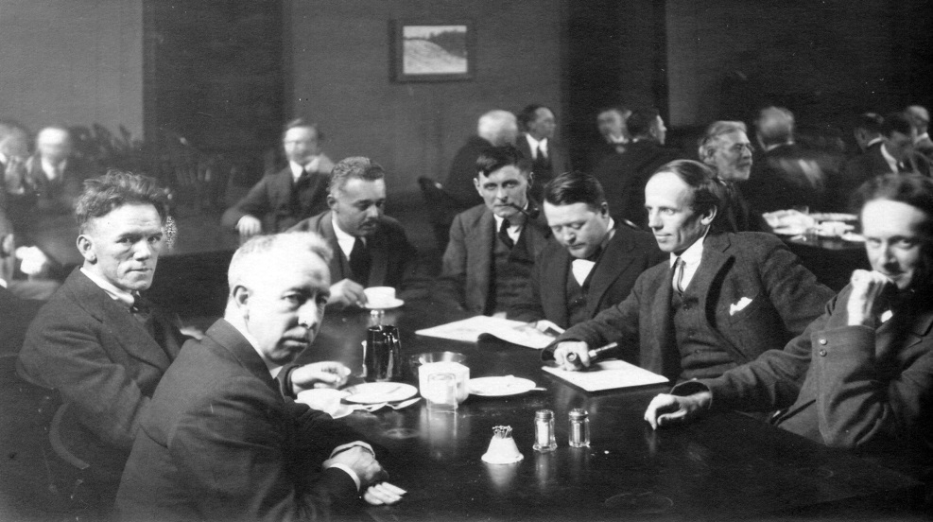
Artistic Statement Template Name:__________
Artwork Title ___________________________________
Remember to read through the “Writing an Artistic Statement” for guideline to complete this sheet. This is available online or ask Mrs. Lamb for it.
- Infleunce(s) and research from past works: Research Notes on Group of Seven Artists (Note: give history of the work of art you are going to reproduce)

- Drawing and painting techniques I used in my work and how they support my intended visual message:

Name _____________
Achievement Criteria | Level 0 | Level 1 | Level 2 | Level 3 | Level 4
Thinking/Inquiry  Concept & Meaning: | Work does not meet assignment expectations for this category.  Incomplete. | Student depicts Group of Seven work of art with limited effectiveness. | Student depicts Group of Seven work of art with some effectiveness. | Student depicts Group of Seven work of art with considerable effectiveness. | Student depicts Group of Seven work of art with a high degree of effectiveness | /1
Knowledge/  Understanding | Work does not meet assignment expectations for this category.  Incomplete. | Student demonstrates limited understanding of the elements & principles of design in reproduction. | Student demonstrates some understanding of the elements & principles of design in reproduction. | Student demonstrates considerable understanding of the elements & principles of design in reproduction. | Student demonstrates a high degree of understanding of the elements & principles of design in reproduction. | /1
Application/  Creation  Process:  Demonstration of skill development and following Procedures including clean up  Completion/  Neatness  Detail – uses elements and principles of design and painting techniques to produce an effective artwork | Work does not meet assignment expectations for this category.  Incomplete.  0  Incomplete  0  Incomplete  0 | Preliminary research is poor/incomplete. Planning is tentative or non-existent.  0.5  Student demonstrates limited effectiveness in demonstrating the creative process and following procedures  4  Limited details  /1 | Preliminary research is  somewhat clear and complete. Planning is somewhat substantial & shows some alternative ideas.  1  Student demonstrates some effectiveness in demonstrating the creative process and following procedures  5-6  Some demonstrating of details present  2-3 | Preliminary research is mostly complete. Concepts are complete.  Planning is evident & shows some divergent thinking.  1.25-1.75  Student demonstrates considerable effectiveness in demonstrating the creative process and following procedures  7-8  Demonstrates considerable and effective details  /4 | Preliminary research is thorough & complete. Concepts are fully developed.  Planning is exceptional & shows considerable thinking  2  Student demonstrates superior effectiveness in demonstrating the creative process and following procedures  9-10  High degree of details present and art work is highly effective  /5 | /2  /10  /5
Reflection Questions | Incomplete  0 | Poor, Yes/No answers/ limited/ incomplete  0.25 | Somewhat coherent and somewhat complete  0.50 | Clear and substantial answers  0.75 | Superior and insightful answers  1 | /1
 |  |  |  |  |  | /20

