Name _______ **Exterior Photomontage Landscape Photography**

"Landscape photography is the supreme test of the photographer – and often the supreme disappointment." - Ansel Adams

Ansel Adams- Monolith, The Face of Half Yosemite Valley,California c. 1927.

**What does Landscape mean?**

**Landscape**: comprises is the visible features of an area of land, including physical elements such as landforms, living elements of flora and fauna, abstract elements such as lighting and weather conditions. Most landscape photographers strive to show as little human activity as possible, ideally none, in their photos. Instead, the subjects are landforms, weather, and ambient light.

**What does Montage mean?**

The word **Montage** comes from the French verb monter “to put together”. Montage can be used to describe a wide range of creative practices that could include photography, film, and sound. Assembling techniques can include but are not limited to repetition, juxtaposition, sequencing, appropriation, and manipulation. **Cape Dorset, 1942-1943**  
 Photo : Peter Pitseolak, Inuit Artist  
 Archives du Musée canadien des civilisations  Peter Pitseolak,

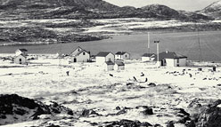[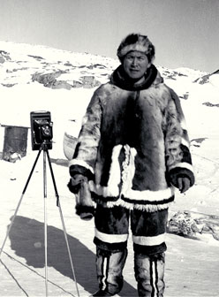](http://www.museedelhistoire.ca/cmc/exhibitions/hist/biography/images/pitseolak-chro-portrait1b.jpg) **“Consider This…”** for photography

• Strong point of Interest

• Location

• Time of Day/Night

• Rule of Thirds

• Foreground to Background relation

• Use lines to lead the eye

**Canadian Contemporary Photography**

Artist: Lorraine Gilbert, The Crossing, from the series, Icelandic Walks, Lightjet on Duraflex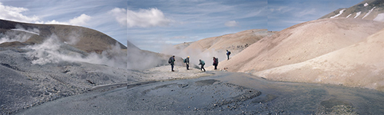

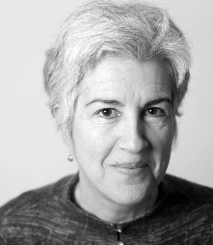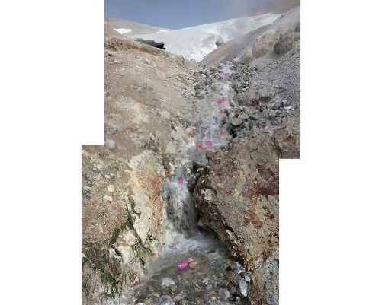 “These photographs were made during a walking trip in Iceland with other Canadian and Icelandic artists, during a project entitled Without A Trace. I am interested in the difference between 'the landscape' as an ideal or essential vision and the nature that it represents in this age of 'experience-byproxy'. In our urban environments, we have learned to ignore distinctions between the authentic and the fabricated. When I walk with other artists in such a place as Iceland, our eyes are wide with disbelief and wonder.” “I decided to work on the idea of the pixel as space within a landscape and I also gave myself complete liberty to reinterpret the walks we took: people and objects were placed in different locations than where they were photographed. I still consider that this work documents the expeditions, because I only used photographs of people who were there with me, in the places where we went. This continues my interests in juxtaposing fact and fiction within a documentary practice.” - Lorraine Gilbert

**Understanding How Photographs Communicate**

Here are a few of the techniques and strategies by which a photo conveys meaning:

**Angle**: The vantage point or direction from which the artist photographs the subject.

**Framing**: By deciding where the edges of the image will be, the photograph determines what you will (and will not) see—whether the subject will fill the frame and appear “close up” or will be seen at a distance as part of a larger context.

**Light**: Light is one of the most powerful tools of the photographer. The manipulation of light and dark and the sharpness of contrast between light and dark contribute to the mood a photograph conveys.

**Focus**: The clarity or blurriness of the image. The range between the nearest and farthest things that appear in clear focus defines the photograph’s depth of field.

**Composition**: What is in the foreground? Are the elements arranged in any particular pattern? Do you see any geometric shapes? Are the lines of the photograph straight or curving, thick or thin? Do any visual elements repeat? Is the visual weight of the photograph balanced: on each side? Top to bottom? Diagonally?

(Adapted from Susan Schekel, personal communication, Stony Brook University)

**Learn to use Adobe Photoshop** - <http://www.wikihow.com/Use-Adobe-Photoshop-Tools>

STEP ONE: ANSWER: the questions on the next sheet by researching online.

STEP TWO: WRITE: Proposed Investigation Statement: Before taking the photograph, explain your chosen theme and reason for this choice.

REVIEW: the above “Things to Consider” points before taking your photographs. In Adobe Photoshop you will put together your photos to make one large landscape montage photograph.

STEP THREE: WRITE: Reflection Statement: After taking the photographs: Suggest ideas for improvement (Remember to use 6 elements and principles in your written explanation.)

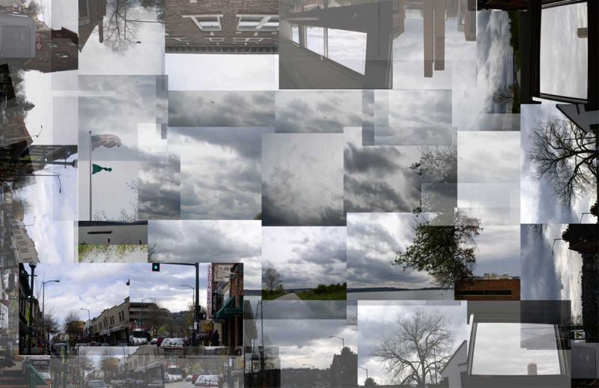

Exterior Photomontage Landscape Questions Name:______________ / 25

1. Why could it be important to include a strong point of interest in taking a landscape photo? (1)

2. List 3 possible subject matter that could appear in the foreground of a picture that could be used to create a strong point of interest? (3)

1.

2.

3.

3. In landscape photography, why could it be important to place the point of interest off-centre? (1)

4. In landscape photography why is line important? (1)

5. Why is time of day important when taking landscape photos? (1)

6. Why is it important to often turn off your flash when shooting outdoors? (1)

7. Why is it important not to put the horizon line right in the middle of your composition? (1)

8. What kind of effect can a silhouette create in landscape photography? (1)

9. Select one Ansel Adams or Lorraine Gilbert photograph and a write a formal critique on it. (10)

Follow the Art Critique format: Description, Analysis, Interpretation and Judgement – (Remember to use 6 elements and principles (Line, Shape, Form, Texture, Balance, Rhythm, Pattern, Contrast, Emphasis, Value, Space, Movement, Colour, Variety, Proportion, Unity) in your written explanation.)

Name _____________ **Exterior Photomontage Landscape Photography**

|  |  |  |  |  |  |  |
| --- | --- | --- | --- | --- | --- | --- |
| Achievement Criteria | Level 0 | Level 1 | Level 2 | Level 3 | Level 4 |  |
| Thinking/Inquiry  Concept & Meaning: Theme of Intended visual message | Work does not meet assignment, Expectations for this category of assessment. Incomplete. 0 | Concept/Theme is unclear and/or weak. Meaning or ideas conveyed are not on par with student’s grade level. 0.25 | Concept/Theme is slightly unclear and/or weak. Meaning or ideas conveyed are below expectations for student’s grade level. 0.25-0.50 | Concept/Theme is clear and valid. Meaning or ideas conveyed are on par with student’s grade level.  0.60-0.75 | Concept/Theme is clear and strong. Meaning or ideas conveyed are above expectations for student’s grade level.  1 | /1 |
| Knowledge/  Understanding Compositional Planning: Elements & Principles of Design | Work does not meet assignment expectations for this category.  Incomplete. | There is limited understanding of composition and the elements of design, limited evidence of planning. 0.25-0.50 | Student demonstrates some understanding of the elements & principles of design in composition. 0.50-1.0 | Student demonstrates considerable understanding of the elements & principles of design in composition  1.5 – 1.75 | Student demonstrates a high degree of understanding of the elements & principles of design in composition  2 | /2 |
| Application/  Creation  Process:  Demonstration of skill development and following procedures including clean up  Finishing & Minimum Size  (8 X 11’’) | Work does not meet assignment expectations for this category.  Incomplete.  0  Incomplete.  0 | Limited demonstration of the design and creation processes and following procedures; Transfers concepts, skills, and procedures to image(s) with limited effectiveness.  5  The work appears obviously poorly finished /improper size. 0.25 | Some demonstration of the design and creation processes and following procedures; Transfers concepts, skills, and procedures to image(s) with moderate effectiveness.  6-6.5  The work appears slightly poorly finished /improper size. 0.25-0.50 | Considerable demonstration of the design and creation processes and following procedures; Transfers concepts, skills, and procedures to image(s) with considerable effectiveness.  7-7.5  The work has considerable finish and proper size. 0.65-0.75 | Superior demonstration of the design and creation processes and following procedures; Transfers concepts, skills, and procedures to image(s) with a high degree of effectiveness.  8-10  The work has superior finish and proper size. 1 | /10  /1 |
| Communication Clarity of Concept/Theme/ Intended Message  Written Evidence of creative process:  1. Written Response: planned investigation to theme (Choice of Subject & Connections to Intended Message)  2. Reflection Statement: Before taking Photograph (Expectations)  3. Reflection Statement: After taking Photograph (Results, Reflection)  Writing Process Evidence: Use of elements and principles of design to describe/make connections to intended visual message | Incomplete.  0  Incomplete. 0  Incomplete. 0 | Work demonstrates a limited degree of clarity in  concept. 0.25-0.50  Limited evidence of the creative process. No combination of: Written Response of planned investigation to theme, Reflection Statement: Before, Reflection Statement: After. (1) 0.25-0.50  Evidence conveys poor connections made employing limited (1) of the elements and principles of design to communicate literal, expressive and design qualities of intended visual message 0.25-0.50 | Work demonstrates some degree of clarity in concept.  0.5-1.0  Some evidence of the creative process. Combination of: Written Response of planned investigation to theme, Reflection Statement: Before, Reflection Statement: After. (1.5) 0.5-1.0  Evidence conveys some connections made employing some (2-3) of the elements and principles of design to communicate literal, expressive and design qualities of intended visual message. 0.5-1.0 | Work demonstrates considerable degree of clarity in concept.  1.5 – 1.75  Acceptable evidence of the creative process. Combination of: Written Response of planned investigation to theme, Reflection Statement: Before, Reflection Statement: After. (2) 1.5 – 1.75  Evidence conveys good connections made employing most (3-5) of the elements and principles of design to communicate literal, expressive and design qualities of intended visual message. 1.5 – 1.75 | Work demonstrates a high degree of clarity in concept.  2  Superior evidence of the creative process. Combination of: Written Response of planned investigation to theme, Reflection Statement: Before, Reflection Statement: After. (3) 2  Evidence conveys superior connections made employing the majority (6+) of the elements and principles of design to communicate literal, expressive and design qualities of intended visual message. 2 | /2  /2  /2 |
|  |  |  |  |  |  | /20 |

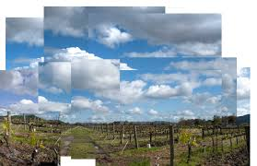 **David Hockney**