1.1.1: What is art?
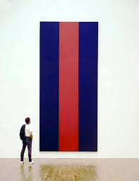  Newman, Barnett. Voice of Fire. 1967. Acrylic on Canvas (540 cm × 240 cm). National Gallery of Canada, Ottawa.  The painting above was purchased for 1.8 million dollars with taxpayer money by the National Gallery in 1989. It caused a huge controversy at the time. In 2015 the painting was valued at 40 million dollars. | This question is not really a very useful question but, we can say that all human cultures that have existed throughout history have all created artifacts. Artifacts need not be art (or maybe they are).  An artifact is simply an object created by a human being. In this course we're going to consider a number of artifacts from a broad range of cultures and historical periods. You might find that some are art (by your definition) and some may be tools or practical spaces (by your definition).  In order to clarify your own thinking about art and artifacts you need review some ideas about art, how we might define it and whether or not there is a distinction between art and artifact.  Let's begin by examining the thinking of some clever people like the Greek philosopher Plato, the revolutionary artist and thinker Marcel Duchamp and other interesting folks. Follow the link below and read through the responses. If you're thinking right now that you're going to have to develop your own definition of art, you're correct! As you read, think about what the term "art" means to you. Do you agree or disagree with the famous thinkers and more importantly, why do you agree or disagree?  You will also want to check out a dictionary definition (or two). You can also do a quick search of the Internet to see what other ideas about art are out there. There are video presentations, slide shows, university courses and a host of other resources to help you come up with your own definition. Have fun and be safe on the web!  When you're finished reading and thinking, move on to the next page for your first assignment. The link below will open a new browser window. You can begin your research in this new window.  27 Responses to the Question, "What is Art?"  (Web note: The website "mental_floss" is a magazine that attempts to bring interesting topics to their readers.) http://www.mentalfloss.com/article/57501/27-responses-question-what-art

