Pencil Vs Camera Project
Name:____________
Ben Heine is a Belgian multidisciplinary artist. Starting as a painter and political cartoonist, he became more widely known in 2011 for his "Pencil vs Camera" series. The idea of mixing drawing with photography came to him in 2010. Heine says it was the result of a long graphic exploration and a logic consequence of his artistic evolution.
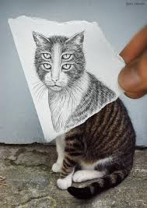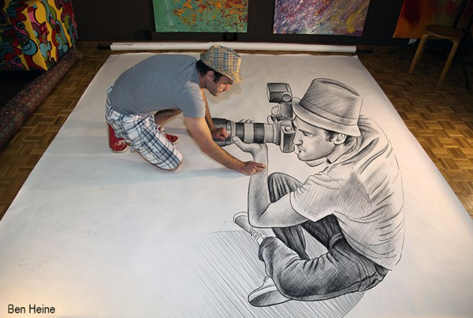
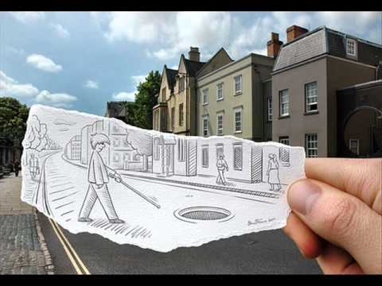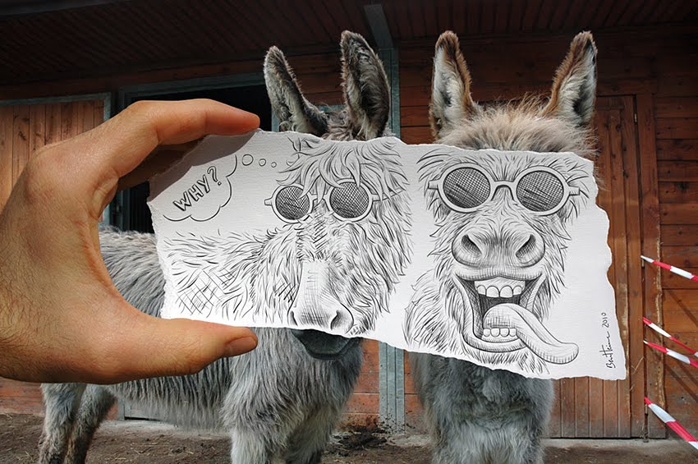
Pencil vs Camera mixes drawing and photography imagination and reality, through illusion and surrealism. In this project, Heine's usually focuses on architecture, portraits and animals. Among many others, the main themes approached in Pencil Vs Camera are love and friendship. Heine says: "I just make art for people. I want them to dream and forget their daily troubles. I used to write poems many years ago, I want to convey a poetic meaning into my pictures, each new creation should tell a story and generate an intense emotion, like a poem, like a melody". This series had a large impact on the graphic design community. Heine says the initial idea of this "Pencil Vs Camera" concept came by coincidence while he was writing a letter. Some of his Pencil vs Camera creations have also been related to optical illusions.
STEP ONE: RESEARCH Ben Heine’s work on the computer.
STEP TWO: DRAW: 3 different conceptual sketches of your subject matter for your own Pencil Vs Camera mixed media project decide how you will break up your chosen image. (on architecture, portraits and animals)
CONSIDER: Line, Form, Unity and Balance; Foreground/ background unity relationship between line and shape. Have your sketches approved by the teacher before starting your large drawing/photo source.
WRITE your Artistic Statement Template to document your artistic process.
STEP THREE: REFLECT: Answer the following questions using the elements and principles of design and hand them in with your completed photo/drawing for evaluation.
1. What part of your finished project did you find most successful and why?
2. What part of your finished project did you find least successful and why?
3. If you had to do this project, what part would you change or improve on and why?

Pencil/Camera Mixed Media
Artistic Statement Template
Name:____________
Artwork Title:______________________________________________
A) Influence(s) and research (Ben Heine) from past and present works:
B) Drawing/Photography techniques used in my work and how they support my intended visual message:
C) REFLECT by answering the following questions using the elements and principles of
design.
1. What part of your finished project did you find most successful and why?
2. What part of your finished project did you find least successful and why?
3. If you had to do this project, what part would you change or improve on and why?

