Torus Sculpture Project NAME:______________
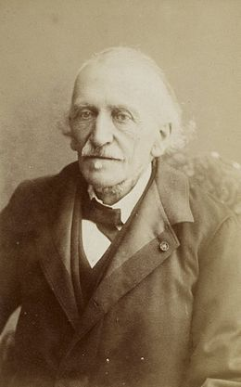 Yvon Villarceau (1813–1883) 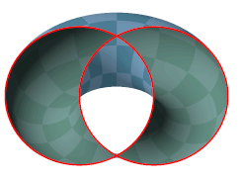
Villarceau circles as intersection of a torus and a plane
In geometry, Villarceau circles are a pair of circles produced by cutting a torus obliquely through the center at a special angle. Given an arbitrary point on a torus, four circles can be drawn through it. One is in the plane (containing the point) parallel to the equatorial plane of the torus. Another is perpendicular to it. The other two are Villarceau circles.
They are named after the French astronomer and mathematician Yvon Villarceau (1813–1883). Mannheim (1903) showed that the Villarceau circles meet all of the parallel circular cross-sections of the torus at the same angle.
STEP ONE: LOOK at the following assembled photos of the Torus Sculpture.
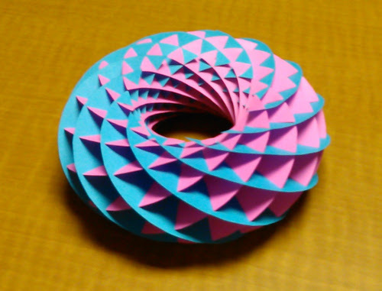 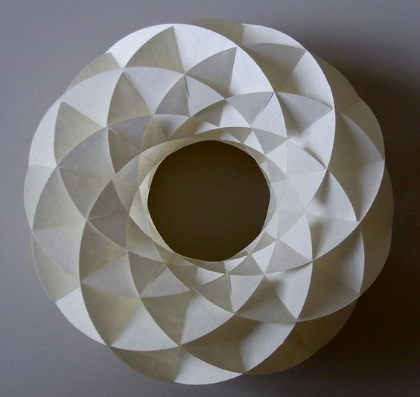
Torus from Villarceau Circles Sculpture Yoshinobu Miyamoto Villarceau Circles Sculpture
STEP TWO: EXAMINE the template to see how the Torus Sculpture interconnects to make one work of art.
STEP THREE: CUT out the Torus Sculpture template with scissors.
STEP FOUR: ASSEMBLE the Torus Sculpture template by bending and curving the individual pieces of paper.
STEP FIVE: WRITE your Artistic Statement Template to document your artistic process.
STEP SIX: REFLECT: Answer the following questions using the elements and principles of design and complete your Artistic Statement Template for formal evaluation.
1. What part of your finished project did you find most successful and why?
2. What part of your finished project did you find least successful and why?
3. If you had to do this project again what would you change or improve?

Artistic Statement Template Name:____________
Artwork Title:______________________________________________
After researching -
A) Influences from past and present works:

1. Who is Yvon Villarceau? (1)

2. What is a Villarceau circles? (1)

B) Sculpture and Assemblage techniques used in my work and how they support my intended visual message:

